**Contoso**

**Microsoft Cloud Adoption Plan**

**Executive Summary**

Contoso is seeking to transform their products and services to capture new business opportunities. To achieve this goal, they are modernizing their core business products for origination and servicing of loans. Once complete, Contoso anticipates the ability to onboard a new business partner in less than three months. While on the cloud adoption journey for a number of years, Contoso has begun to standardize on Azure and seeks to implement features that will allow rapid/iterative development and feedback.

As Contoso continue to adopt cloud principles, we want to ensure that there is continuous improvement and progress. Short sprints are imperative to this principle, we will build minimal viable projects and then continue to evolve, this phased approach will optimize for speed and efficiency.

**Define Strategy**

Motivations and drivers

|  |
| --- |
| **Short-term (Horizon 1)**   * ***Reliability, Scalability, Agility, Security*** - Datacenter exit Q2 * ***Profitability*** - Ability to provide cost of acquisition/operations for partners * ***Business Value Realization*** - Financial justification   **Medium-term (Horizon 2)**   * ***Optimize Operations*** - Data segmentation for business partners * ***Innovation*** - Enable developers and business units to rapidly build new services   **Long-term (Horizon 3)**   * ***Enable Business Agility*** - Move existing assets to micro services as a means of driving greater efficiency |

Business outcomes

Below we have captured the objectives by individual in the Strategy and Plan workshop. Later in in the adoption plan we will look at the applications and workloads which help achieve the business drivers.

**NOTE**: it would be pertinent for the Contoso to look at how these business outcomes are operationalized. One way to ensure that business objectives are carried through Contoso is to implement objectives and key results (OKRs). OKR is a framework for defining and tracking objectives and their outcomes. It helps drive accountability and alignment across the organization. [Workboard](https://www.workboard.com/) is a partner who can be contracted to assist in defining this.

|  |  |  |  |  |  |  |
| --- | --- | --- | --- | --- | --- | --- |
| Stakeholder: | Nicola Washington | |  | Outcome: | Decrease Time to Market for onboarding new Partners | |
|  |  |  |  |  |  |  |
| Business Drivers | | |  | KPI |  | Capabilities |
| Increase Revenue  Capture New Markets | | |  | Onboard process less than 3 months |  | -Infra as Code to enable automation  -Granular details on cost by partner to increase profitability |

|  |  |  |  |  |  |  |
| --- | --- | --- | --- | --- | --- | --- |
| Stakeholder: | Thomas Ace | |  | Outcome: | Providing the “ility” platform | |
|  |  |  |  |  |  |  |
| Business Drivers | | |  | KPI |  | Capabilities |
| Guaranteed SLA’s  Optimize Loan Servicing | | |  | TBD (need from Contoso) – How can we measure success here? |  | -Micro Services  -API centric architecture |

|  |  |  |  |  |  |  |
| --- | --- | --- | --- | --- | --- | --- |
| Stakeholder: | Fredrica Smith | |  | Outcome: | Transforming IT | |
|  |  |  |  |  |  |  |
| Business Drivers | | |  | KPI |  | Capabilities |
| Staying ahead of the business to drive value | | |  | List success metrics |  | List necessary capabilities |

Business justification

* Contoso seeks to create a financial model to showcase the long-term cash savings of the migration. In addition, provide deeper analytics for the fully burdened cost by partner enabling the ability to increase profitability. Microsoft can partner with Contoso financial teams to build out a financial modelling to support the onboarding of new partners.

* **Example Model**: HA/DR in Azure
  + Capital Expense Reduction

|  |  |  |
| --- | --- | --- |
| Line Item | On Prem | Azure |
| Hardware Refresh (annualized) |  |  |
| Licensing costs (annualized) |  |  |
| Insurance |  |  |
| Facility Expense |  |  |
| Staff for Operations |  |  |
| Maintenance contracts |  |  |
| Other |  |  |
| Consumption Costs (Azure) |  |  |
| TOTAL |  |  |

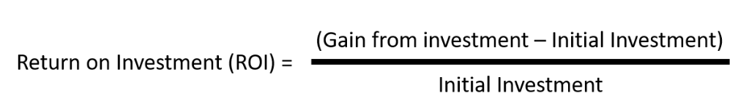

Organizational alignment and Stakeholders

It is essential that as we adopt cloud we think about the individuals and roles that they will play in the future service delivery model. As iterated before “Cloud is a model, not just a place”. This will mean that we need to thing about how we leverage teams to be more agile and respond to ever changing demands. We need to ensure that the teams can help drive alignment and accountability.

There are many ways that we can align the organization, the recommendations below are based on what we see with other customers and will start with the principle of a minimal viable product (MVP) and then evolve as Contoso progresses with the adoption.

Our guidance is to start with 2 teams, a **Cloud Strategy Team** and a **Cloud Governance Team**

The **Cloud Strategy Team** is responsible for leading the cloud adoption within your organization, supporting all business outcomes, people and processes changes and technical projects identified within this plan. The types of roles typically found in the strategy team are:

* Finance
* Line of business
* Human resources
* Operations
* Enterprise architecture
* IT infrastructure
* Application groups
* Project managers (Often with Agile project management experience)

The **Cloud Governance Team** ensures that risks and risk tolerance are properly evaluated and managed. This capability ensures the proper identification of risks that can't be tolerated by the business have the correct governing corporate policies. Here are some of the roles which we believe form part of your Governance team:

* IT governance
* Enterprise architecture
* Security
* IT operations
* IT infrastructure
* Networking
* Identity
* Virtualization
* Business continuity and disaster recovery
* Application owners within IT
* Finance owners

|  |  |  |  |  |
| --- | --- | --- | --- | --- |
| Name | Business Unit/Role | Business Outcome Owner (Y/N) | Cloud Strategy Team (Y/N) | Cloud Governance Team (Y/N) |
| Nicola Washington | VP Shared Services | Y | Y | Y |
| Thomas Ace | Senior Director – Architecture | Y | Y | Y |
| Fredrica Smith | Senior Director – Infrastructure | Y | Y | Y |
| Jane Brown | IT Finance | Y | N | Y |
| Pravesh Sharma | Security Director | N | N | Y |
| Frank Rogers | Operations Director | N | N | Y |
| Anita Johnson | CIO | Y | Y | N |
| Nasen Reddy | Head of business applications | Y | Y | N |
| Nicole Ang | Enterprise Architect | N | N | Y |

Below is a view of the evolution of the Strategy / Governance teams, the ideal end state is to have a Cloud Center of Excellence which drives cloud adoption across the organization.

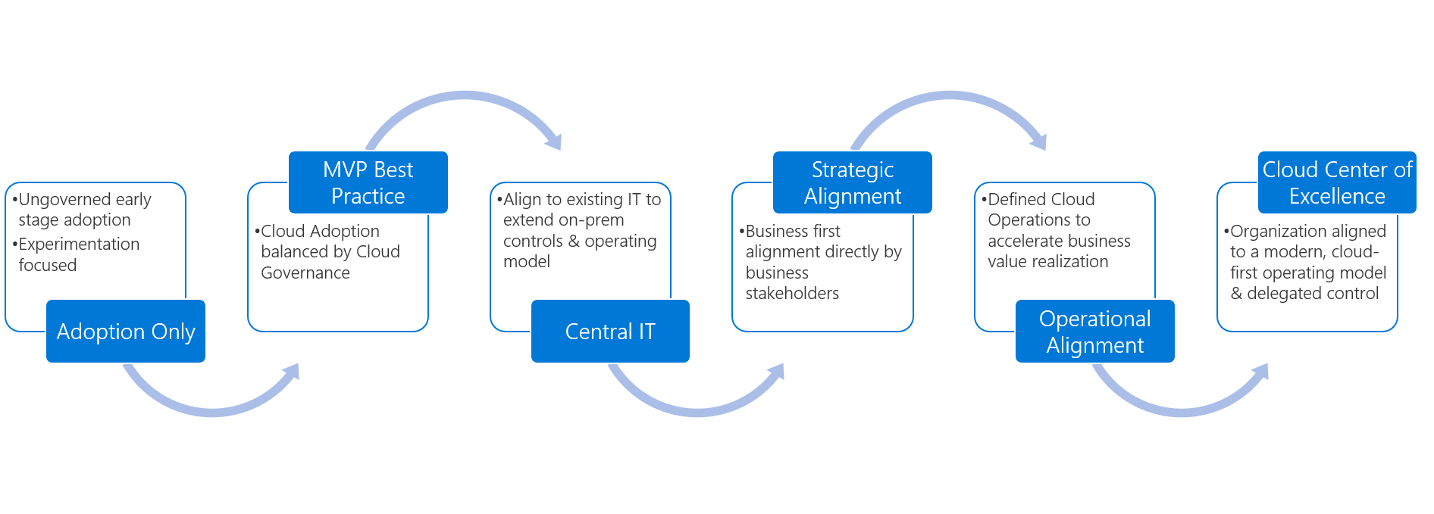

For context, here is a RACI model for a Cloud Center of Excellence. It is important as the cloud journey evolves to have representation across the business to address the complexity of the transformation.

|  |  |  |  |  |  |  |  |  |
| --- | --- | --- | --- | --- | --- | --- | --- | --- |
|  | **Solution delivery** | **Business alignment** | **Change management** | **Solution operations** | **Governance** | **Platform maturity** | **Platform operations** | **Platform automation** |
| Cloud strategy team | C | A | A | C | C | I | I | I |
| Cloud adoption team | A | C | R | C | I | I | I | I |
| Cloud operations team | C | C | R | A | C | I | A | C |
| Cloud governance team | C | I | I | C | A | C | R | I |
| Cloud platform team | C | I | I | C | C | A | R | R |
| Cloud automation team | C | I | I | I | C | R | R | A |
| Aligned cloud capability | Cloud adoption | Cloud strategy | Cloud strategy | Cloud operations | CCoE-Cloud governance | CCoE-Cloud platform | CCoE-Cloud platform | CCoE-Cloud automation |

More information on the teams can be found here:

<https://docs.microsoft.com/en-us/azure/cloud-adoption-framework/organize/>

**Plan**

Digital estate

Below is a list of prioritized workloads and applications which were identified during the Strategy and Plan workshop. These applications and workloads align back to the core motivations and business objectives. Our suggested is to consider take an ‘incremental’ approach in this journey, meaning don’t try to list all your targets in your first attempt but grow them over time as you revisit this plan.

|  |  |  |  |
| --- | --- | --- | --- |
| Application/Workload | Business Unit | Business Priority (high, mid, low) | Proposed Rationalization |
| Origination application | Origination | High | Refactor – Cloud Native |
| DR and BC plan | Shared Services | High | Lift and Shift |
| DevOps LLE | DevOps | Mid | Cloud Native |
| Rise application prod to move to Azure – end of CY2020 Q2 ** | Shared Services | High | Refactor – Cloud Native |
| Datascience team to move to Azure – Internal | Risk Analysis | Mid * | Greenfield Development |
| Datacenter exit – CY2020 Q2 | Shared Services | High | Refactor/Lift and Shift |
| Hadoop cluster migration - Need DR capability (integration with existing environment) | Shared Services | Low | Replatform |
| Teradata – Synapse | Risk Analysis | Low | Refactor/Lift and Shift |
| SharePoint / Fileshares migration | Shared Services | Med | Lift and Shift |
| Dynamics to Cloud | Origination | Med | Yet to be evaluated |
| VDI | Shared Services | Low | Yet to be evaluated |
| R&D connectivity to onpremise environment – security posture / governance rules | R&D | Med |  |

Skills readiness plans

For successful cloud adoption, it’s critical to ensure your people, IT and non-IT, are [ready](https://docs.microsoft.com/azure/architecture/cloud-adoption/plan/adapt-roles-skills-processes) for this transformation. Including in the table below, the key courses your organization needs to take for this process.

|  |  |  |  |  |
| --- | --- | --- | --- | --- |
| Course name | Audience (Cloud Architect, IT, Admin, Ops) | Level  (100, 200, 300, 400) | Source  (MS Learn, Pluralsight, ESI) | Priority  (high, mid, low) |
| [Microsoft Cloud Adoption Framework for Azure](https://docs.microsoft.com/en-us/learn/modules/microsoft-cloud-adoption-framework-for-azure/index) | Admin, Devs, Cloud Architect, Business User, Cloud Engineer | 100 | MS Learn | High |
| [Azure Fundamentals](https://docs.microsoft.com/en-us/learn/paths/azure-fundamentals/) | Admin, Devs, Cloud Architect, Business User, Cloud Engineer | 100 | ESI | High |
| [Learn the Business Value of Azure](https://docs.microsoft.com/en-us/learn/paths/learn-business-value-of-azure/) | Business User | 100 | MS Learn | Mid |
| Microsoft Azure Administrator | Admin, Devs, Cloud Architect, Cloud Engineer | 200 | ESI | High |
| Microsoft Azure Architect | Cloud Architect, Cloud Engineer | 300 | ESI | High |

[Suggested](https://docs.microsoft.com/azure/architecture/cloud-adoption/plan/suggested-skills) skills are included in here, and more information on available, free, on-demand Azure technical readiness at [MS Learn](https://docs.microsoft.com/en-us/learn/).

Azure Environment

Below are the key principles and rules which will be applied to the Contoso environment.

**Management Group Structure** – the management group structure should reflect the Contoso business structure and where accountabilities reside. We will use an organizational unit design model for the management of resources.

* Root - Contoso
* Tier 1 – Business Units (Origination, Processing, Shared Services, R&D, Finance, HR)
* Tier 2 – Geography (to support future expansion and the need to deliver unique rules to specific locations)

**Subscription Model**

* Decisions for how to handle subscriptions
* Subscriptions for Prod, Non-Prod, QA, DevTest

**Tagging and Naming Rules**

The following table includes naming patterns for a few sample types of Azure resources.

| **Entity** | **Scope** | **Length** | **Casing** | **Valid characters** | **Suggested pattern** | **Example** |
| --- | --- | --- | --- | --- | --- | --- |
| Resource group | Subscription | 1-90 | Case insensitive | Alphanumeric, underscore, parentheses, hyphen, period (except at end), and Unicode characters | <service short name>-<environment>-rg | profx-prod-rg |
| Availability set | Resource group | 1-80 | Case insensitive | Alphanumeric, underscore, and hyphen | <service-short-name>-<context>-as | profx-sql-as |
| Tag | Associated entity | 512 (name), 256 (value) | Case insensitive | Alphanumeric | "key" : "value" | "department" : "Central IT" |

For additional naming patterns: <https://docs.microsoft.com/en-us/azure/cloud-adoption-framework/ready/azure-best-practices/naming-and-tagging>

**Network diagram** – below is the network schema

<insert network diag>

**Role based authentication**

* All rights will be assigned through groups rather than individuals, this simplifies maintenance and provides consistent access thus reducing configuration errors.
* Below is a view of the common roles for dividing IT responsibilities:

| **Group** | **Common role name** | **Responsibilities** |
| --- | --- | --- |
| Security Operations | SecOps | Provides general security oversight.  Establishes and enforces security policy such as encryption at rest.  Manages encryption keys.  Manages firewall rules. |
| Network Operations | NetOps | Manages network configuration and operations within virtual networks, such as routes and peerings. |
| Systems Operations | SysOps | Specifies compute and storage infrastructure options and maintains resources that have been deployed. |
| Development, Test, and Operations | DevOps | Builds and deploys workload features and applications.  Operates features and applications to meet service-level agreements (SLAs) and other quality standards. |

**Cost Management –** enables Contoso to track spending, all resources in Azure will be tagged for the correct cost allocation and tracking.

* Policies will be applied to enable / allow certain Azure resources – these policies can be adjusted through the governance council.
* Implementation of cost management will be through Azure Cost Management, budgets will be applied to each scope and visible to budget owners.
* Alerting will be established to meet requirements for business insight

**Security Baseline** – the SecOps team along with the governance team establish security rules to protect internal assets and customer data.

* <outline the basic set of rules which will apply>
  + Production rules
  + Non-production rules
  + Dev/Test rules

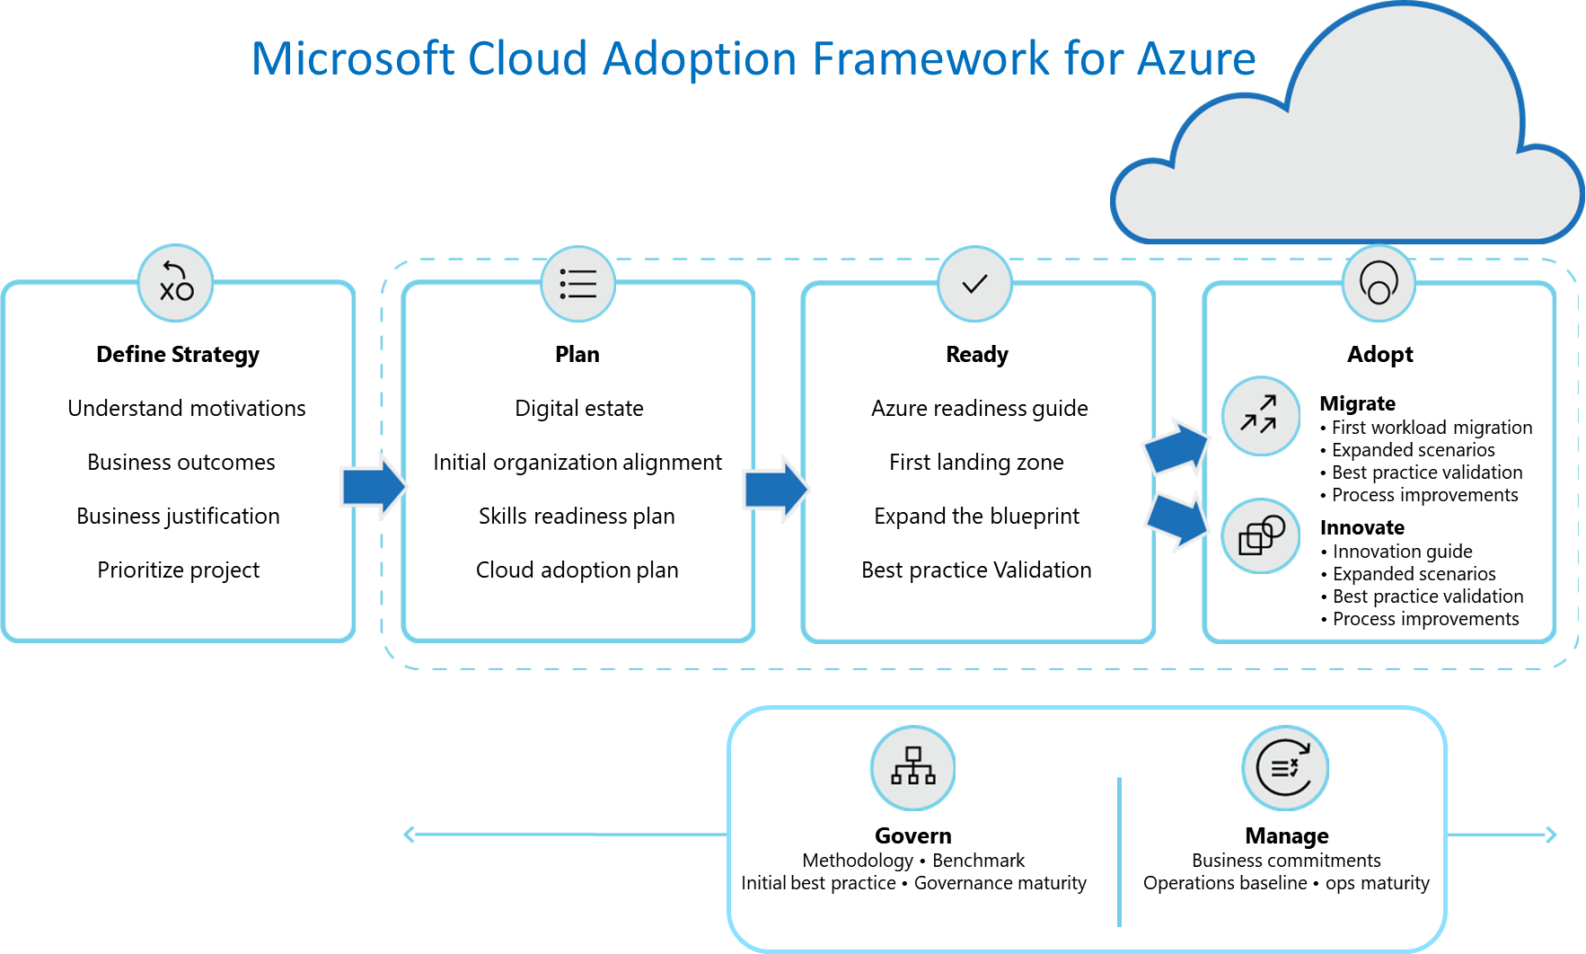

<https://aka.ms/cloudadoptionframework>